Pune Institute of Computer Engineering
Dhankawadi, Pune-411043

WTL MINI PROJECT REPORT

ON

LOGIN AND REGISTRATION SYSTEM

SUBMITTED BY
Name:
31323 Pradip Funde
31330 Akash Jadhav
Class: TE 03

Under the guidance of
Prof. Parag A. Jambhulkar


DEPARTMENT OF COMPUTER ENGINEERING
Academic Year 2023-24

Contents

1 TITLE
2 PROBLEM DEFINITION
3 ABSTRACT
4 INTRODUCTION
5 TECH STACK
6 DESCRIPTION OF MODULES
7 DESCRIPTION OF MONGODB SCHEMA AND MODEL
8 GUI INTERFACE
9 USE CASE DIAGRAM
10 TEST CASES
11 CONCLUSION

Title: LOGIN AND REGISTRATION SYSTEM

Problem Definition:

Develop a React-based restaurant website with a dynamic menu display and engaging content. Implement a secure and user-friendly login and registration system to enhance user interaction and streamline the online dining experience.

Abstract:

In the modern digital era, restaurant websites serve as crucial touchpoints for customer engagement and online interactions. This project employs the MERN stack, comprising MongoDB, Express.js, React, and Node.js, to develop a sophisticated restaurant website. The frontend, crafted using React, features a dynamic menu display, engaging content sections, and a responsive design, offering an intuitive user interface and seamless navigation. On the backend, Express.js facilitates robust API development, enabling secure user registration and login functionalities. Leveraging MongoDB, the project ensures data persistence and integrity, storing user information securely. By integrating these technologies, the project aims to enhance user interaction, streamline the online dining experience, and establish trust through a secure and user-friendly login and registration system, exemplifying best practices in full-stack web development.

Introduction:

In the digital age, restaurant websites have become indispensable tools for engaging customers, showcasing offerings, and facilitating online interactions. This project embarks on the development of a sophisticated restaurant website using the MERN stack, a powerful combination of MongoDB, Express.js, React, and Node.js, known for its scalability and efficiency in full-stack web development. Leveraging the dynamic capabilities of React, the frontend is designed with a responsive layout, featuring a dynamic menu display and engaging content sections, ensuring an intuitive user interface and seamless navigation. Complementing the frontend, the backend utilizes Express.js to develop robust APIs, enabling secure user registration and login functionalities. With MongoDB handling data storage and ensuring data integrity, the project exemplifies best practices in full-stack web development, aiming to enhance user interaction, streamline the online dining experience, and foster trust through a secure and user-friendly login and registration system.

This project addresses the challenges faced by diners and restaurant owners in the digital age. For diners, navigating restaurant websites can be cumbersome, while restaurant owners often grapple with inefficient reservation systems. Our application aims to streamline this process by offering an intuitive platform for diners and efficient management tools for restaurant administrators. Leveraging the MERN stack, we combine React's dynamic frontend with Express.js APIs for secure user functionalities, revolutionizing the online dining experience and empowering restaurant owners to optimize their operations.

Tech Stack:
Frontend Technologies: Html, CSS, Javascript, React.js
Backend Technologies: Node.js, Express.js and MongoDB

Description of Modules:

Navbar:
• Purpose: To provide consistent website navigation and branding across all pages.
• Functionality: Displays the restaurant's name and offers links to various pages like Home, About, Menu, Contact, and Login/Logout.

Login:
• Purpose: To authenticate users for accessing exclusive features and making reservations.
• Functionality: Implements a login form where users can enter their email and password for authentication. It communicates with the backend to verify user credentials and grant access upon successful authentication.

Register:
• Purpose: To allow new users to create an account.
• Functionality: Features a registration form where users can enter their name, email, and password to create a new account. It communicates with the backend to store user information securely.

Index (Home) Page:
• Purpose: To serve as the main landing page resembling a restaurant website.
• Functionality: Showcases a hero banner with a title and subtitle, enticing users to explore the restaurant's offerings. It also displays featured menu items and provides links to other pages like About, Menu, Contact, and Login.

About Page:
• Purpose: To provide information about the restaurant, its history, and mission.
• Functionality: Presents details about the restaurant's background, chef, and culinary philosophy, allowing users to learn more about the restaurant and its offerings.

Menu Page:
• Purpose: To display the restaurant's menu items and details.
• Functionality: Displays images, names, and descriptions of menu items, enabling users to explore and select dishes they wish to learn more about or order.

Contact Page:
• Purpose: To provide contact information and a means for users to reach out to the restaurant.
• Functionality: Features a contact form where users can enter their name, email, message, and contact details to send inquiries or feedback to the restaurant. It also displays the restaurant's contact information, including address, phone number, and email.

Description of MongoDB Schema and Model:

FormDataSchema:
• Purpose: To define the structure and data types of documents that will be stored in the MongoDB collection.
• Fields:
• name:
• Type: String
• Purpose: To store the user's name.
• email:
• Type: String
• Purpose: To store the user's email address. This field is also used as a unique identifier to ensure each user has a unique email when registering.
• password:
• Type: String
• Purpose: To store the user's password. It is essential to note that storing passwords as plain text is not secure. In a production environment, passwords should be hashed and salted before storing them in the database to enhance security.

FormDataModel:

• Purpose: To create a model that interacts with the 'log_reg_form' collection in the MongoDB database based on the defined schema.
• Methods:
• mongoose.model('log_reg_form', FormDataSchema);
• log_reg_form: Name of the MongoDB collection.
• FormDataSchema: The schema defining the structure of documents stored in the collection.

• module.exports = FormDataModel;
• Purpose: To export the FormDataModel so that it can be imported and used in other parts of the application to perform CRUD (Create, Read, Update, Delete) operations on the 'log_reg_form' collection.

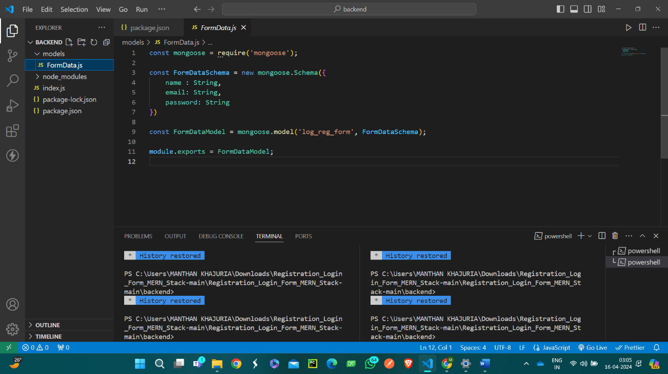

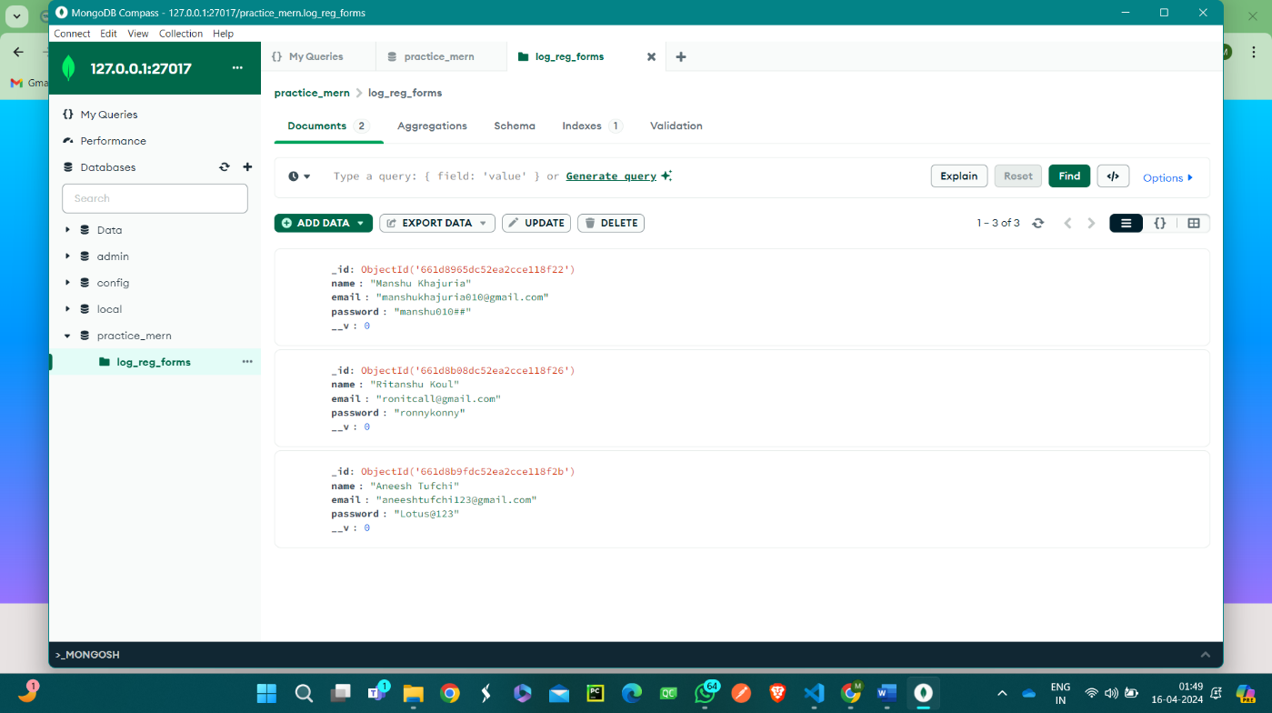

GUI Interface:

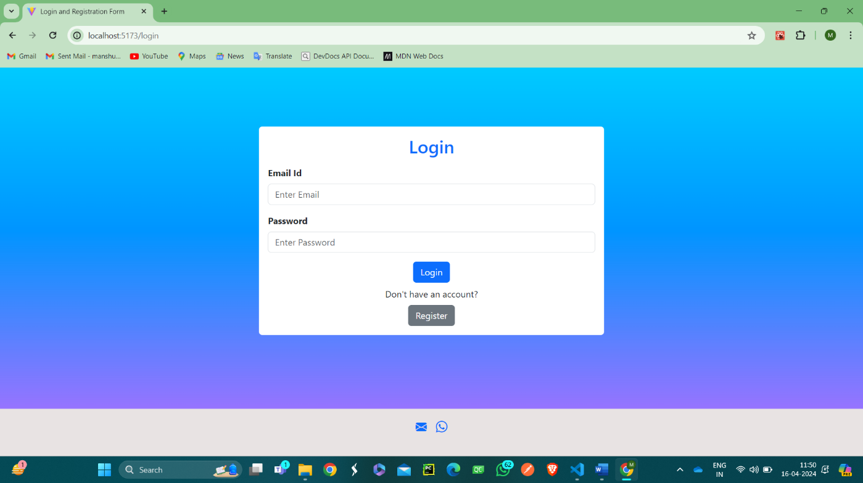

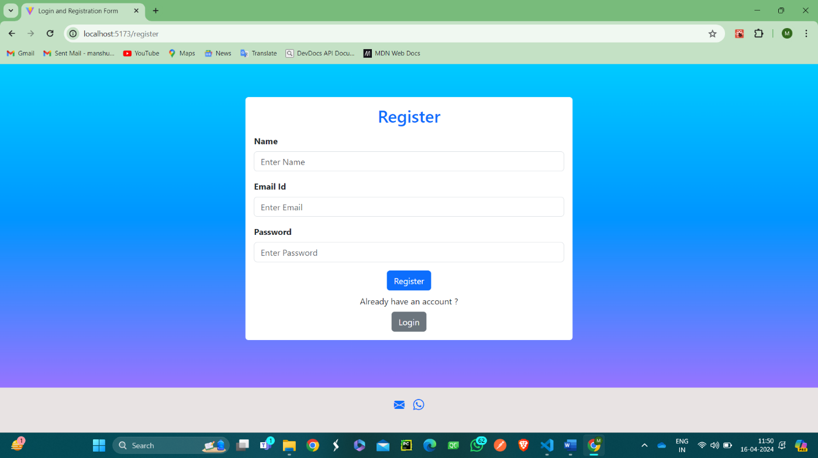

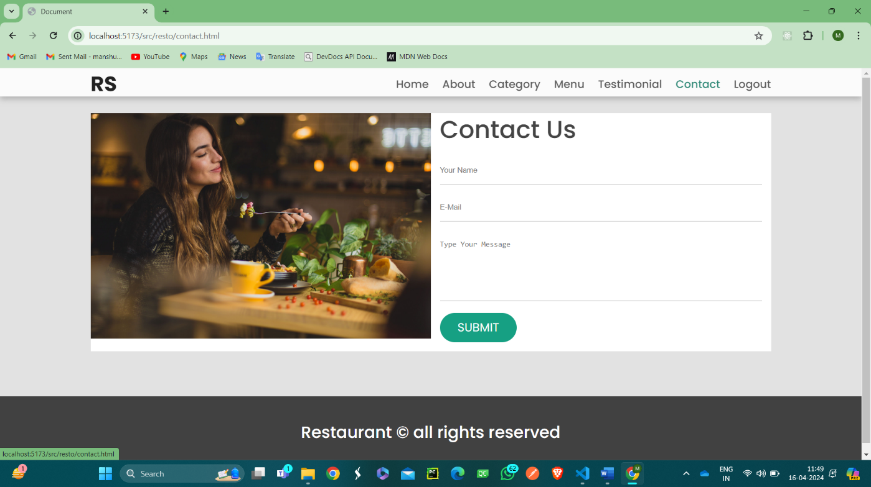

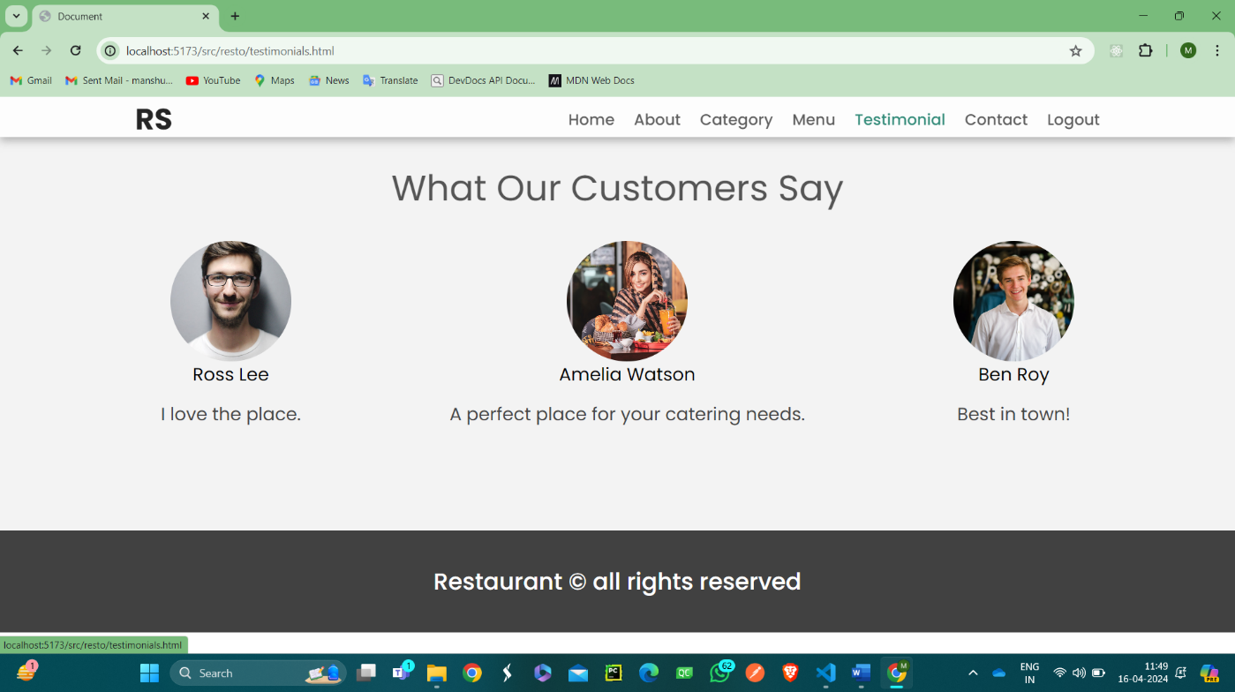

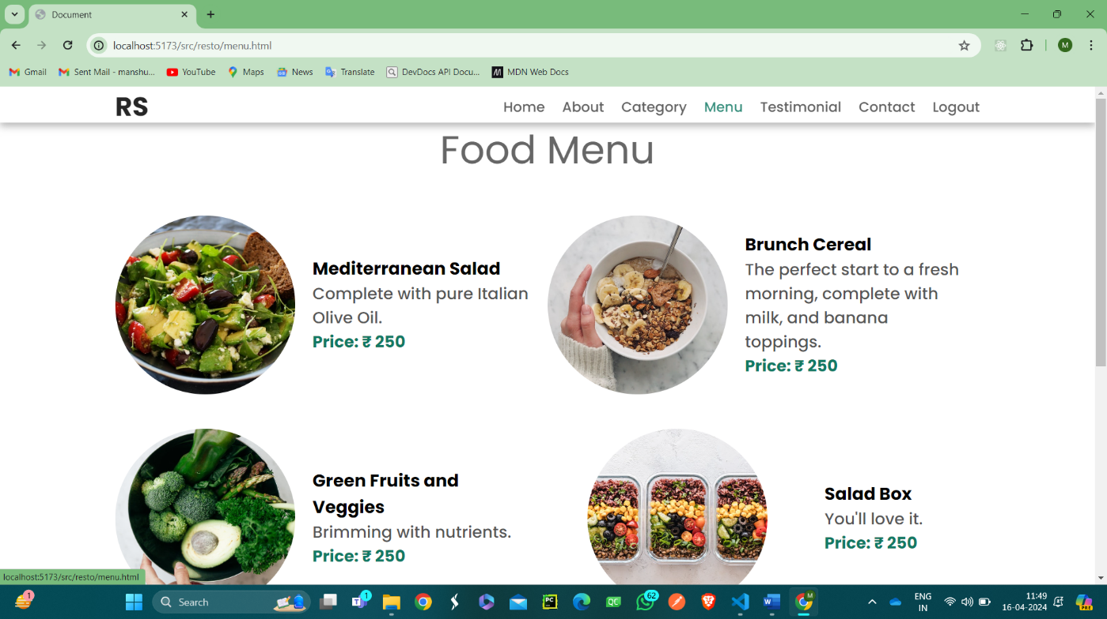

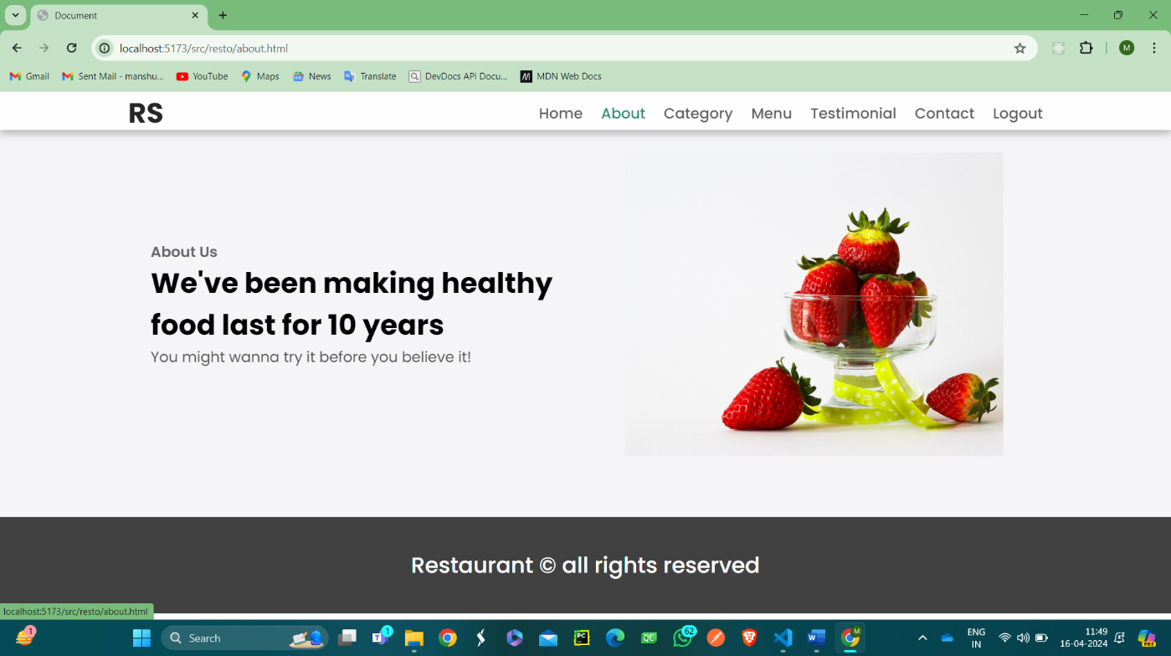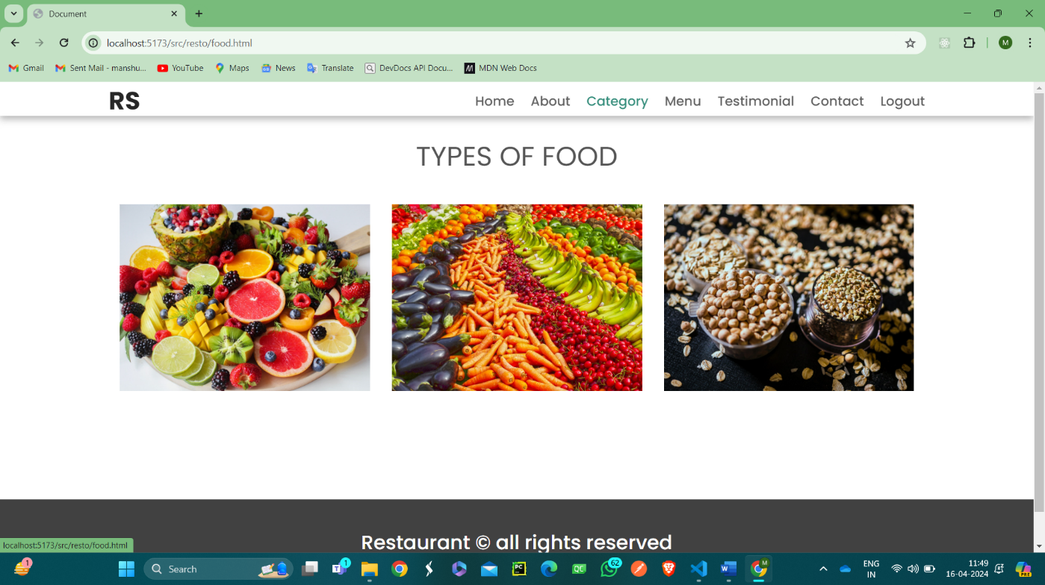

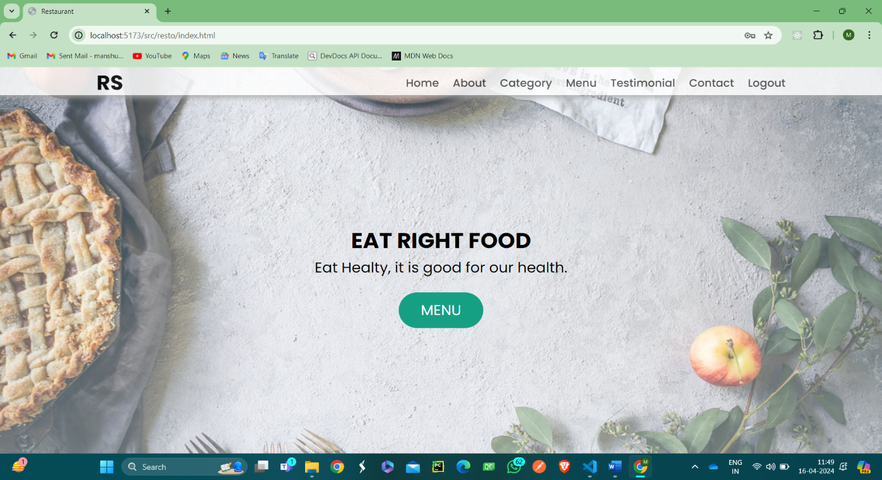

USE CASES:

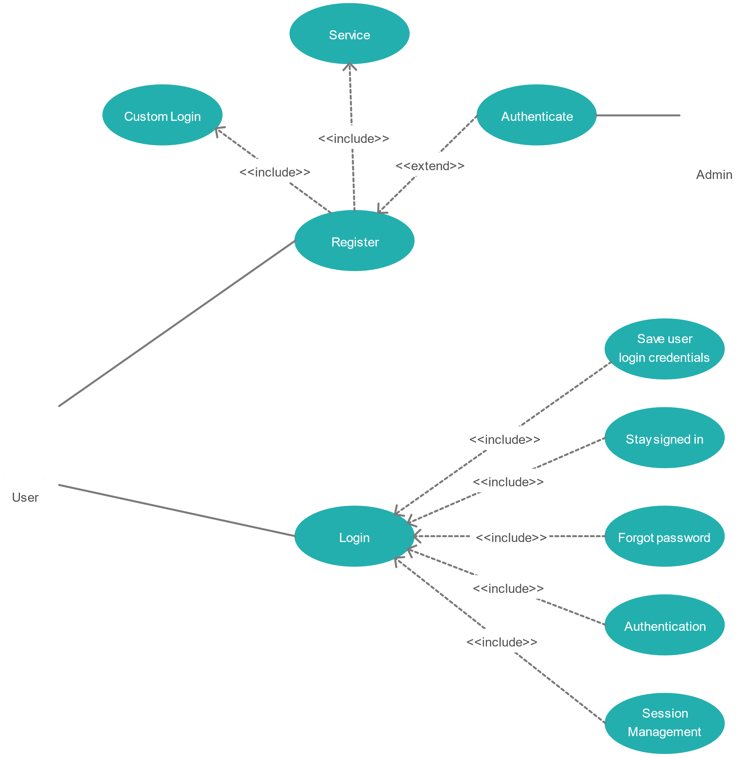

TEST CASES:

LOGIN :

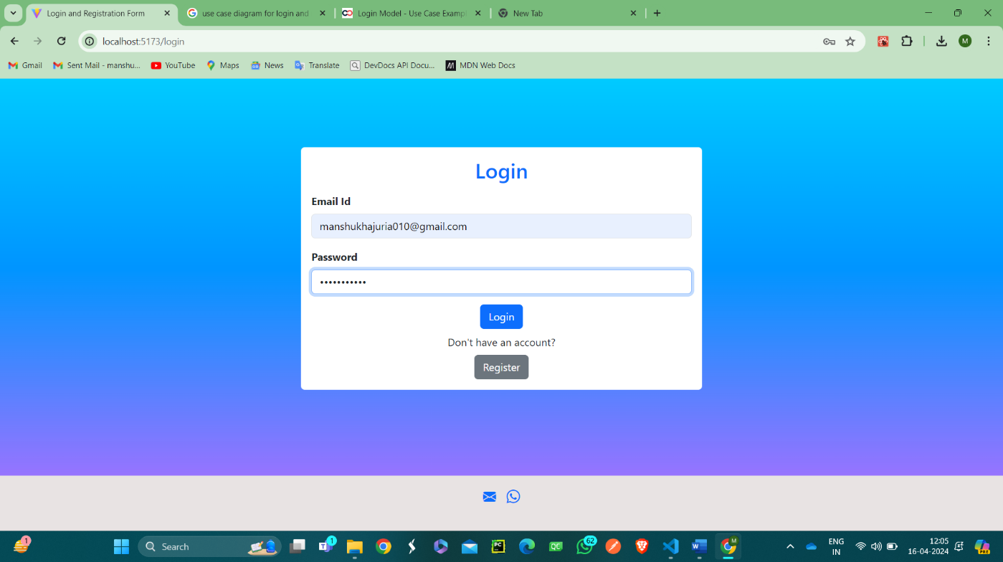

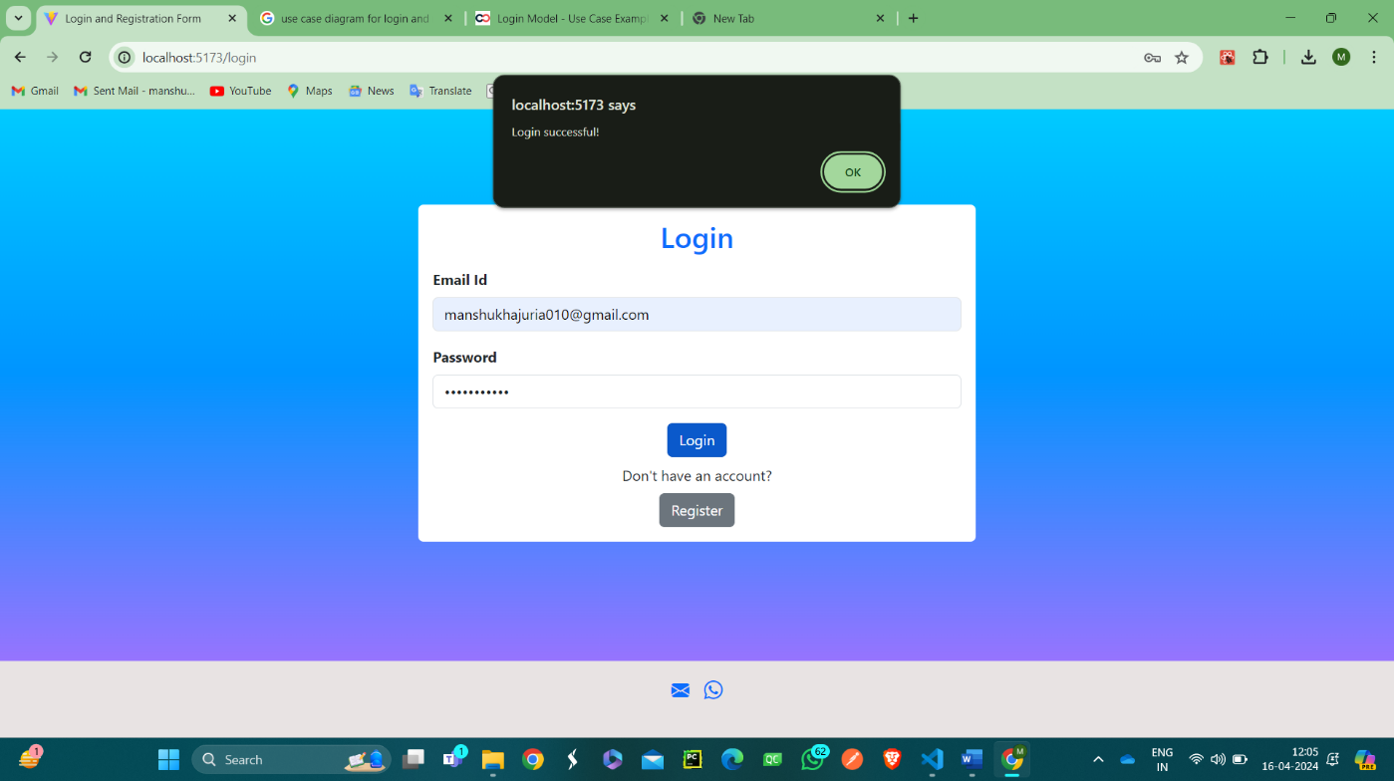

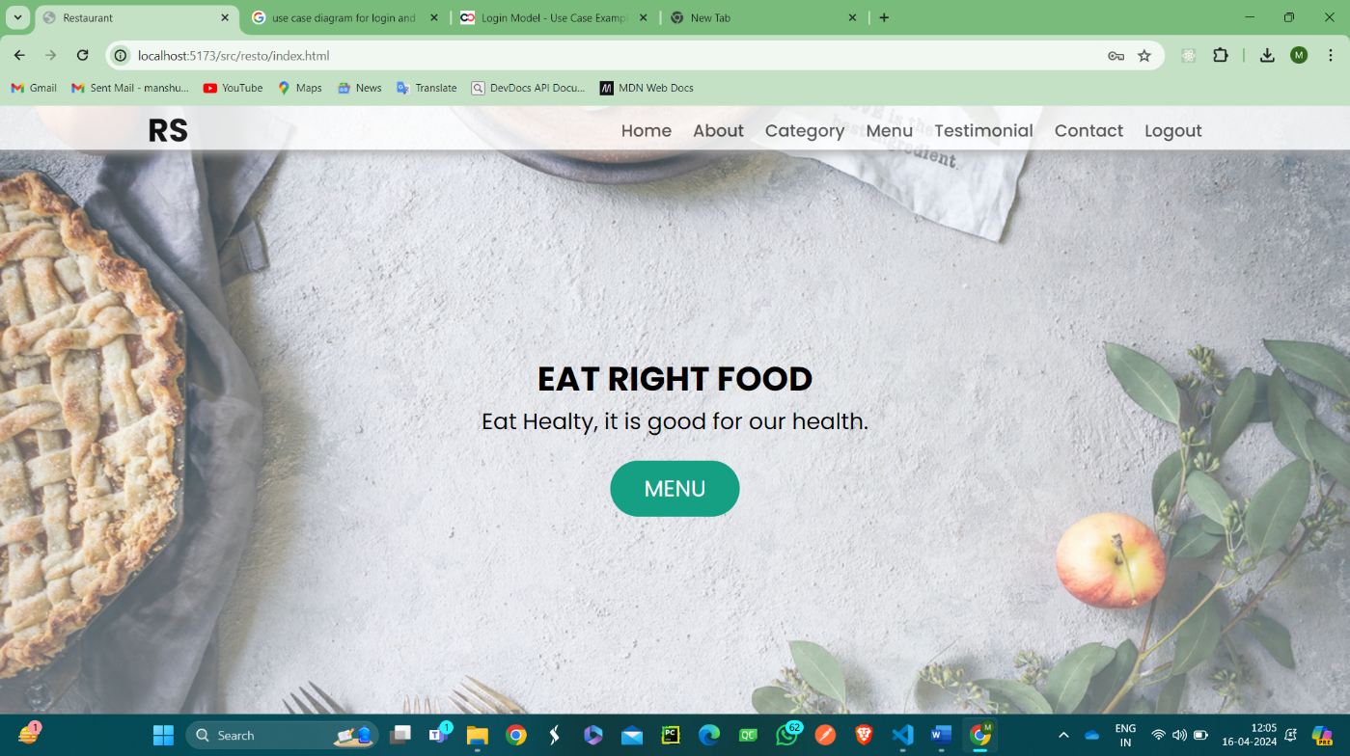

REGISTRATION :

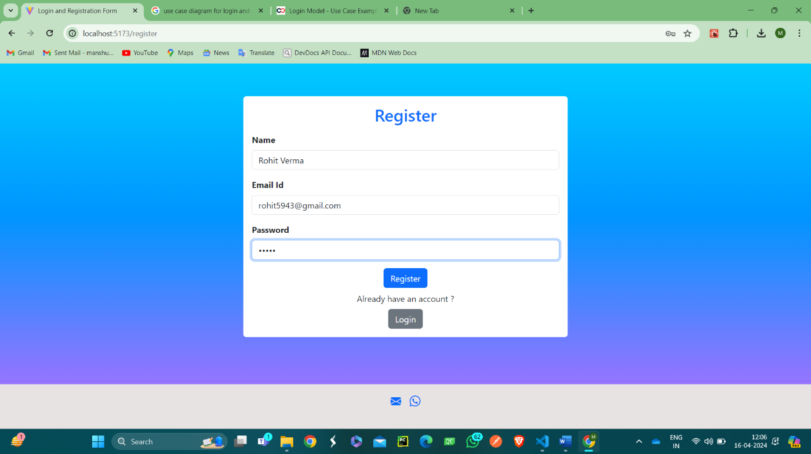

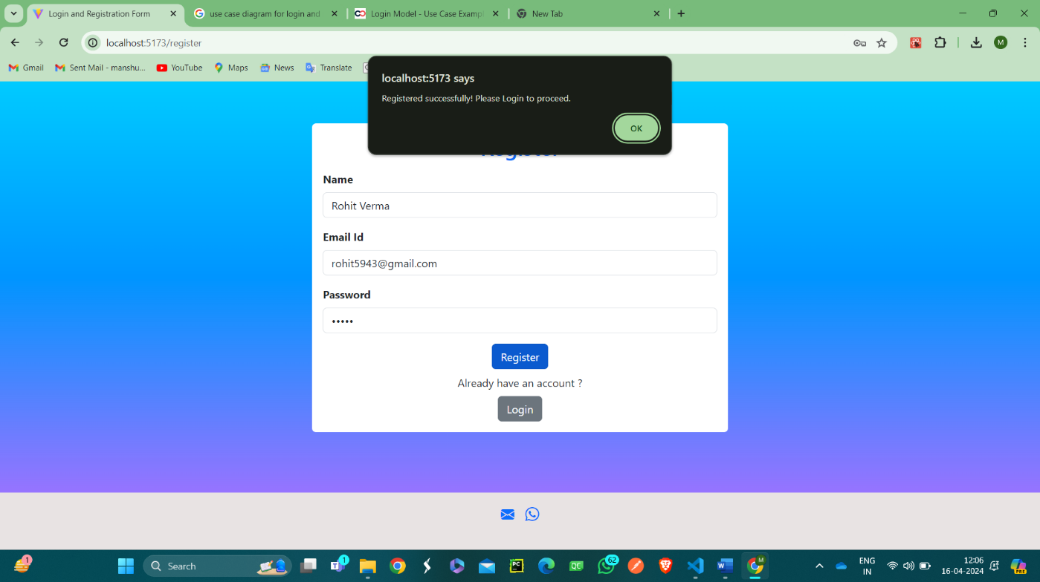

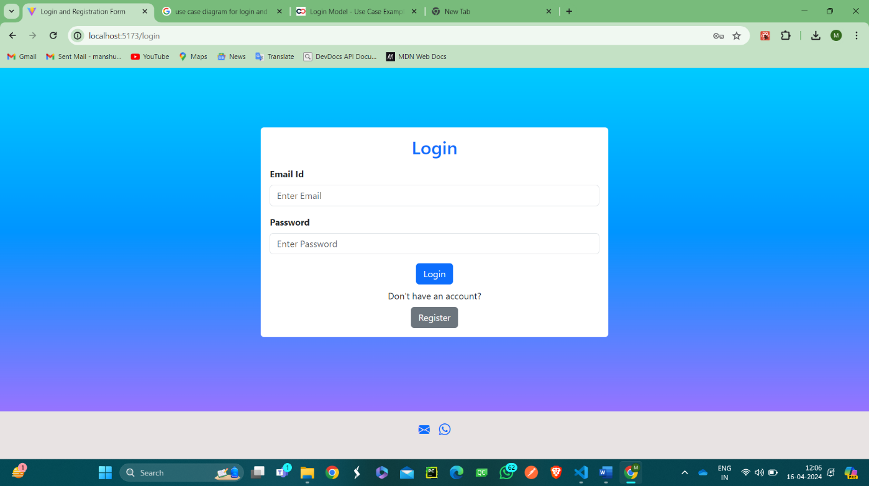

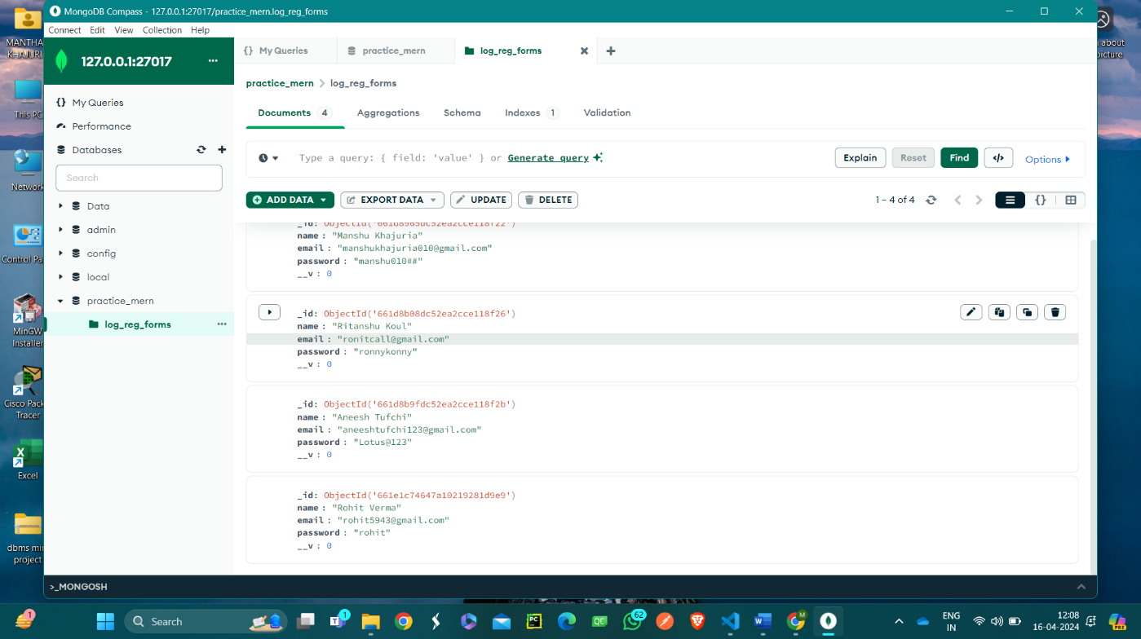

CONCLUSION:

Hence, we successfully built a basic login and registration system and implemented basic CRUD operations on MongoDB database by connecting MongoDB database with NodeJS backend and ReactJS frontend.

